GUINEA
The Alliance entered the vast and unevangelized land of French Guinea in 1919. By 1965, the Evangelical Protestant Church (The Alliance in Guinea) consisted of 144 organized churches and church groups with more than 1,400 baptized members. Within 15 years, the number of churches tripled, and baptized members increased by nearly 4,000.

Africa
- Burkina Faso
- Congo
- Côte D'Ivoire
- Gabon
- Guinea
- Mali
- Senegal
The average person in Guinea lives on one dollar a day. Such poverty, along with the influence of traditional religions, provides many challenges for Alliance workers. Team members are sharing the hope of Jesus through practical acts of kindness, including AIDS counseling, youth ministries, English camps/courses, seminars for business professionals, radio programs on health and community development, and spiritual mentoring.
CAMA (Compassion and Mercy Associates), our relief and development arm, cares for body and soul at Hope Clinic, providing dental and medical treatment to countless people in desperate need. In 2008, clinic workers saw about 19,000 patients, and all received prayer. The clinic is moving toward becoming a complete medical center with a nursing school and national staff.

National Church
L’Eglise Protestante Evangélique (CMA) de Guinée: 437 organized churches, 154 unorganized groups, 176 ordained ministers, 23,230 baptized members, and 67,224 inclusive members

Team Initiatives
- Plant churches among the Fulbe people group. A team of nine C&MA international workers is working in partnership with other missions to see the church of Jesus Christ established among this people group. Pray that many Fulbe would begin responding to the gospel.
- Plant churches among the Maninka people, the second largest Muslim people group in Guinea. Pray for wisdom in selecting a church-planting team leader and members to join the effort in reaching the Maninka for Christ.
- Plant churches among the Susu people. One couple is working with three other missionary families to reach the one million Susus in Conakry. Pray for God to prompt other couples to assist with this effort.

International Workers in Guinea

Conakry Team

Benjamin Anderson

Chelsea Anderson

Chad Clason

Nicole Clason

Doug Petersen

LaShawna Petersen

Arnie Solvig

Cheryl Solvig

Timbi Team

Jacob Howard

Sarah Howard

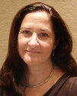Dee Krueger

Mark Krueger

Naomi Lowe

The Alliance at Work in Guinea
- 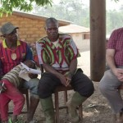

21 Days
Three weeks of health monitoring is crucial to curbing Ebola’s spread.
read more
- 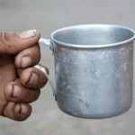

The Blind See
We were led to West Africa, where Mamajan awaited God to fulfill His promise “. . . seek, and you will find.”
read more
- 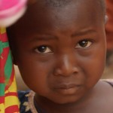

Spiritual Climate Shifts in Guinea
Prayer is key to evangelizing Guinea’s remaining 39 unreached ethnic groups.
read more
- 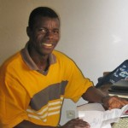

Guinea Ebola Workers’ Killers Sentenced
Rev. Moise Mamy was one of the eight workers killed in September 2014.
read more
- 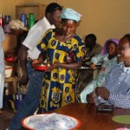

Ebola Conference Equips Guinean Pastors
We’ve seen a church more than double in size because of its response to Ebola victims.
read more
Read more stories

