MALI
The Alliance entered Mali, home of the fabled city of Timbuktu, in 1923. Many Alliance missionaries labored faithfully for more than a decade in this spiritually arid climate before seeing a single convert. Today, less than 1 percent of the Malian people follow Jesus. Yet through God’s grace and the prayers of His people, Alliance workers and their national partners are building communities of faith among previously resistant groups, including the Bozo and the Gana people.

Africa
- Burkina Faso
- Congo
- Côte D'Ivoire
- Gabon
- Guinea
- Mali
- Senegal
The Alliance mission and the national church are proclaiming the hope of Jesus among prostitutes, prisoners, subsistence farmers, and villagers throughout the country. The Bamako Ministry Center is reaching out to university students and professionals, and the Koutiala Hospital ministers Jesus’ compassion to countless women and children who would otherwise die without ever hearing of the Savior’s love for them.

The Alliance at Work in Mali
- 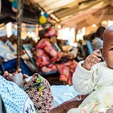

Lives Will Be Saved
One of the many ministries you support through your gift to the Great Commission Fund is critical medical care in developing countries.
read more
- 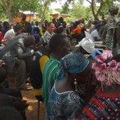

Churches Will Be Planted
One of the many ministries you support through your gift to the Great Commission Fund is church planting.
read more
- 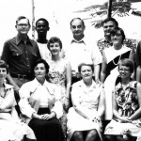

Ordinary People, Uncommon Faith
Is the cost to GO just too great for my generation? The sacrifice too painful?
read more
- 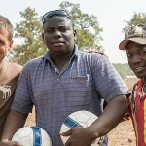

Where Are They Now? – Part 2
Yusuf showed up to watch and was completely captured by the story of Jesus.
read more
- 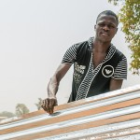

Where Are They Now? – Part 1
“People used to call me a rascal. Now they tell me that I’ve become a serious young man.”
read more
Read more stories

Demographics
Population
Population—12,291,529
Infant mortality rate—116.8/1,000
Life expectancy—45.1
Capital City
Bamako (1,323,200) pop.
Geography
Almost twice the size of Texas, Mali (478,764 sq. mi.) lies in the Sahara Desert. The only fertile area is in the south.
Languages
French (official)
Bambara
numerous African languages
Ethnicity/Race
Mande (Bambara, Malinké, Sarakole)—50%
Peul—17%
Voltaic—12%
Tuareg, Moor—10%
Songhai—6%
other—5%
Economy
Per capita income—$900
Inflation—4.5%
Unemployment—14.6%
Literacy rate—46% (2003 est.)
Government/Political Climate
Republic. Rule by dictatorship ended in 1992 with Mali’s first presidential election.
Religion
Muslim—90%
indigenous beliefs—9%
Christian—1%

Support the Mission
Alliance ministry in Mali is primarily funded through the Great Commission Fund. Help fulfill Jesus’Great Commission and make a gift to the GCF today.
Top of Form
Select an amount
Bottom of Form

Give to Special Projects
These field-approved projects are funded by donations in addition to the GCF. Click and give today.

Bamako Team

Segou Team

Koutiala Team

