Colombia
About › Family › World › Colombia
Alliance missionaries entered Colombia in 1923, and the Colombian C&MA has been organized since 1942. At present there are 250 organized churches with several unorganized churches as well as preaching points around the country. Among Colombia’s 42 million people, about 6 percent are evangelical Christians.
Alliance missionaries are transitioning out of Colombia because a strong national church has been established, and indigenous leaders are shepherding the churches. The goal is to see all church ministries being led by Colombians by the end of 2010 when the C&MA will leave the country.
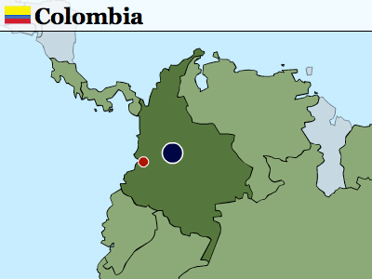

National Church
Colombian Christian and Missionary Alliance: 157 organized churches, 236 unorganized groups, 66 ordained ministers, 32,530 baptized members, and 40,458 inclusive members

Team Initiatives
- Raise up a strong, committed leadership in the Cali West church plant among the upper class.
- Move the U.S. C&MA mission toward transitioning out of Colombia. The exact date depends on when the national church will be strong enough to support itself. Pray for wisdom as our workers press toward this goal.

International Workers in Colombia

The Alliance at Work in Colombia
- 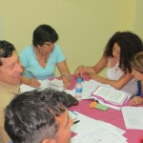

A Mother’s Prayer
A mother’s prayer for her child to be born again is a prayer God loves to answer.
read more

Retired Colombia Missionary Dies
Rev. Oscar W. Jacobson, retired missionary to Colombia, entered into the presence of the Lord on Sunday, February 1, 2009. […]
read more

Doctors Declare a Miracle
In what doctors are calling a miraculous answer to prayer, the daughter of Rev. Humberto Guzman, Colombia C&MA church president, […]
read more

Alliance Pastor Killed
On the morning of July 22, Anibal Molina, pastor of the C&MA Church of Argelia in Cauca, Colombia was killed in […]
read more

Missionaries' Grandbaby Struggles for Life
Hannah Ardis Ord made her entrance into world on October 31 at 1:10 p.m. while her grandparents, Doug and Naomi, […]
read more
Read more stories

Demographics
Population
Population—42,954,279
Infant mortality rate—21.0/1,000
Life expectancy—71.7
Capital City
Santafé de Bogotá (6,837,800) pop.
Geography
A little less than three times the size of Montana, Colombia (439,733 sq. mi.) has three Andean ranges running north and south in the western half of the country. The eastern half is a low, jungle-covered plain.
Languages
Spanish
Ethnicity/Race
Mestizo—58%
White—20%
Mulatto—14%
Black—4%
mixed Black-Amerindian—3%
Amerindian—1%
Economy
Per capita income—$6,600
Inflation—5.9%
Unemployment—13.6%
Literacy rate—93% (2003 est.)
Government/Political Climate
Republic; executive branch dominates government structure. A 40-year insurgent campaign to overthrow the Colombian government escalated during the 1990s, undergirded in part by funds from the drug trade. Although the violence is deadly, the movement lacks the military strength or popular support necessary to overthrow the government.
Religion
Roman Catholic—90%
other—10%

Support the Mission
Alliance ministry in Colombia is primarily funded through the Great Commission Fund. Help fulfill Jesus’ Great Commission and make a gift to the GCF today.

