- Looking for Hope?
- Find Us
- Contact Us
- Search
- Sign In
- Home
- About Us
- Ministries
- Updates
- Events
- Resources
- MyCMA
- Give
- Serve
- Pray
- Mission
- Beliefs
- History
- Family
- Our President

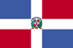Dominican Republic
About › Family › World › Dominican Republic
The Alliance has had an active presence in the Dominican Republic since the mid 1960s when Dominicans living in New York, along with other Hispanic immigrants, sacrificially gave of their time and resources to take the Christ-centered message of the C&MA to their homeland. The church took root and grew, even with the absence of trained pastors or international workers.

Latin America
- Argentina
- Bolivia
- Brazil
- Chile
- Colombia
- Costa Rica
- Dominican Republic
- Ecuador
- Mexico
- Panama
- Paraguay
- Peru
- Suriname
- Uruguay
- Venezuela
In the 1980s, The Alliance sent full-time international workers to the country to work alongside Dominican believers to provide much-needed leadership and theological training and to expand the church into people groups with little evangelical presence.
Today, Alliance workers are involved in a variety of ministries, in many cases working alongside Dominican believers to build Christian communities throughout the country. Creative strategies such as Marriage Encounter, relational evangelism, and youth and family outreaches are among many different approaches being used to share Jesus’ love and expand His Kingdom among urban professionals, one of the least reached groups in the Dominican Republic. The ultimate goal is to multiply strong communities of believers throughout the country who will impact their nation and the world.
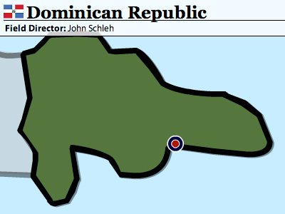

National Church
The C&MA National Church of the Dominican Republic: 37 organized churches (25 members and above), 35 unorganized churches (below 25 members), 11 preaching points (small groups), 19 ordained ministers, 14 pastors, 28 licensed workers, 4 local Dominican missionary church planters

Team Initiatives
- Plant churches among urban professionals.
- Train pastors and lay leadership at the Alliance Bible Institute.
- Develop short-term missions projects.

International Workers in Dominican Republic

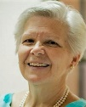Becky Dyke

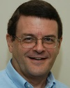Bruce Dyke

Keren Pena

Miguel Rodriguez

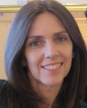Colleen Schleh

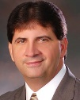John Schleh

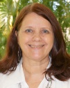Julie Stutler

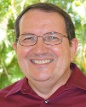Zac Stutler

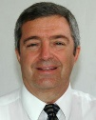Brad Wood

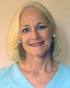Dorothy Wood

Envision Team

Adam Atkinson

Laura Atkinson

Laura Nahas

Bethany Nutter

Brandon Nutter

The Alliance at Work in Dominican Republic
- 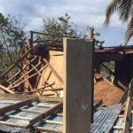

Hurricane Update 9/9
Cuba and Puerto Rico Pummeled, Florida in the Crosshairs, and Texas in Need of Volunteers
read more
- 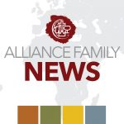

Hurricane Irma Update 9/8
Pray for Florida. Churches in The Dominican Republic are safe, and Envision steps up to shelter displaced refugees.
read more

Initial Report on Hurricane Irma
Puerto Rico faces major blackouts, but dodges catastrophic damage.
read more

8 Photos of Christmas Around the World
See how Christ’s birth is celebrated in various Alliance fields around the world.
read more
- 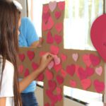

The ‘Jesus Camp’ Touches Young Lives with God’s Love
When a mother asked her son what he wanted to do that week, he said, “I want to go to the Jesus camp.”
read more
Read more stories

Demographics
Population
Population—over 9 million
Infant mortality rate—32.4/1,000
Life expectancy—67.3
Capital City
Santo Domingo—unknown pop.
Geography
The size of Vermont and New Hampshire combined, the Dominican Republic (18,815 sq. mi.) occupies the eastern two-thirds of the island of Hispaniola, which it shares with Haiti. The country’s terrain includes rugged highlands and mountains with fertile valleys interspersed.
Languages
Spanish
Ethnicity/Race
White—16%
Black—11%
mixed—73%
Economy
Per capita income—$6,300
Inflation—55%
Unemployment—17%
Literacy rate—85% (2003 est.)
Government/Political Climate
Representative democracy. Attained independence as the Dominican Republic in 1844. From1966–1996 Joaquin Balaguar was president. Since then, regular competitive elections have been held in which opposition candidates have won the presidency.
Religion
Roman Catholic—95%
other—5%

Support the Mission
Alliance ministry in Dominican Republic is primarily funded through the Great Commission Fund. Help fulfill Jesus’ Great Commission and make a gift to the GCF today.
Top of Form
Select an amount
Bottom of Form

Give to Special Projects
These field-approved projects are funded by donations in addition to the GCF. Click and give today.

Dominican Republic Team
- Church Bldg/Center/S Dom
- Central Alliance Church
- Evangelism Training
- Evangelism Follow Up Literature
- TEE
- Bible Institute
- Cana Segura Church Project
- Punta Cana Church Plant Project
- FATELA Scholarships
- Church Planting Bootcamps
- Encounter Cell Church
- Cape May, NJ/San Marcos Partnership Agreement

Envision Dominican Republic Team
- Ministry Fund- Nutters
- Envision - Dominican Republic
- Envision Dom Rep National Camp

Share
- Share
- Tweet

Get Involved...

Pray.
We cannot “Live the Call Together” unless prayer is central to all we do.
Pray with us »

Serve.
Is God calling you to service? We’re here to help you connect your passion with God’s purpose.
Serve with The Alliance »

Give.
Help build Christ’s Church by supporting the ministry and workers of The Alliance.
Give today »

Get Connected
- Facebook
- Twitter
- Instagram
- MyCMA
- RSS
- Podcast
- Newsletters
- Locate a Church
- Locate an International Worker
- Daily Devotionals
- Press Room
- Employment
- Related Ministries
- Contact
- FAQ
- Privacy Policy
- MyCMA
© 2003 -2017, The Christian and Missionary Alliance-All rights reserved. Some material used by permission.

